COAL LAB 2
ARSH
BAI-3C
23K-0078
TASK 1:
INCLUDE Irvine32.inc

.data
num1 BYTE 25
num2 WORD 300
num3 DWORD 5000

.code
main PROC
mov al, num1
mov bx, num2
mov ecx, num3 ;breakpoint

call DumpRegs
exit
main ENDP
END main

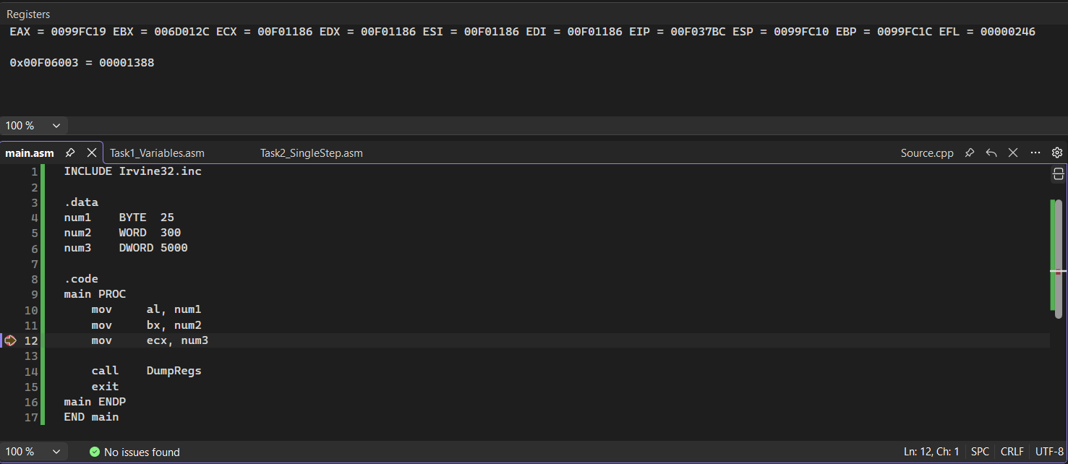
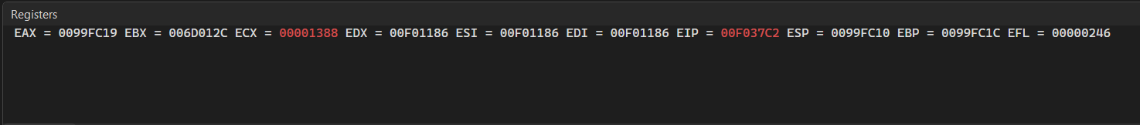
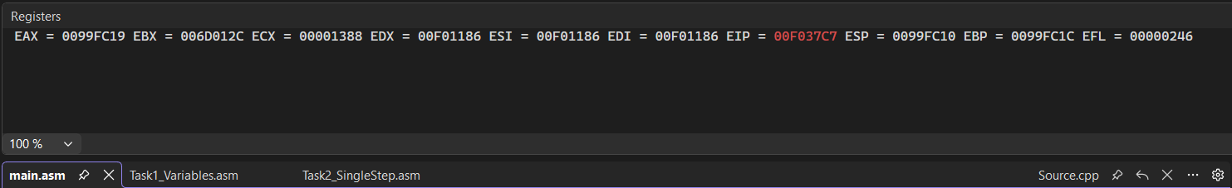
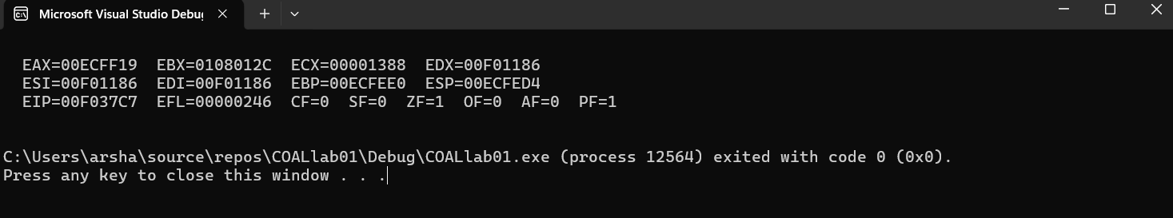

TASK 2:
INCLUDE Irvine32.inc

.code
main PROC
mov eax, 10
add eax, 5 ;breakpoint
sub eax, 3

call DumpRegs
exit
main ENDP
END main

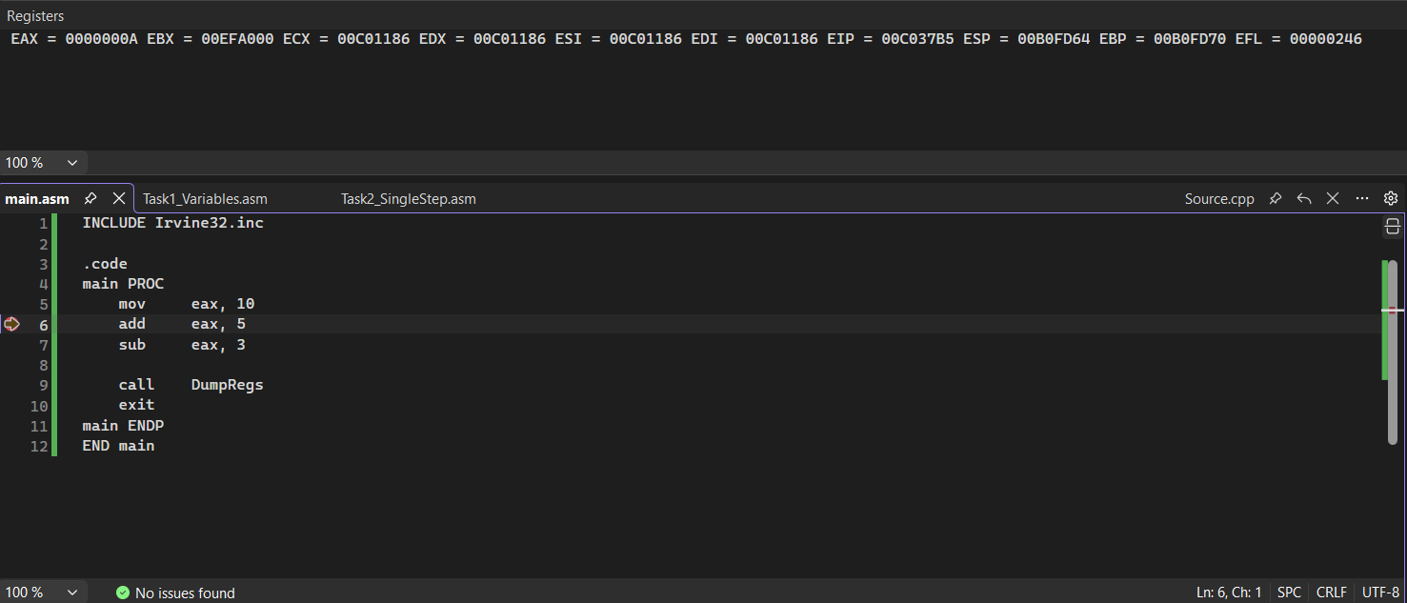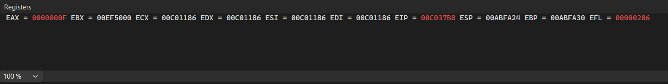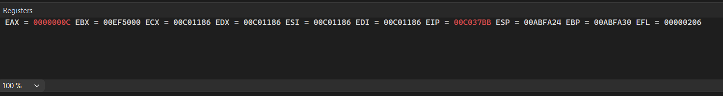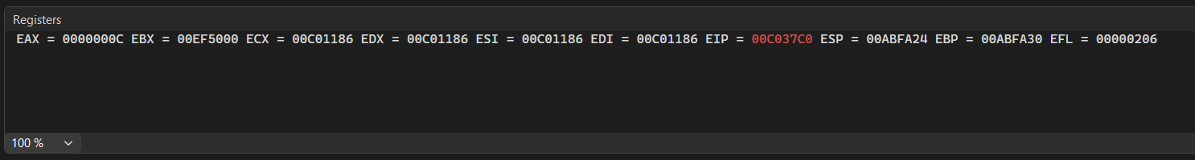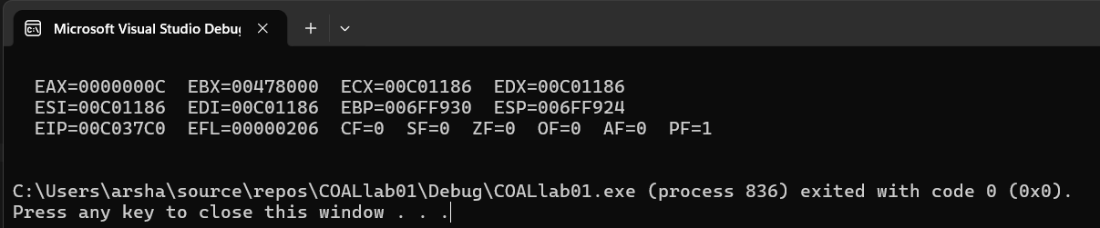
TASK 3:
INCLUDE Irvine32.inc

.data
byteVal DB 120
wordVal DW 4000
dwordVal DD 90000
qwordVal DQ 10000000000
charVal DB 'A'
strVal DB "COAL Lab 2", 0

.code
main PROC
mov al, byteVal
mov bx, wordVal
mov ecx, dwordVal ;breakpoint
mov edx, OFFSET strVal

call DumpRegs
exit
main ENDP
END main

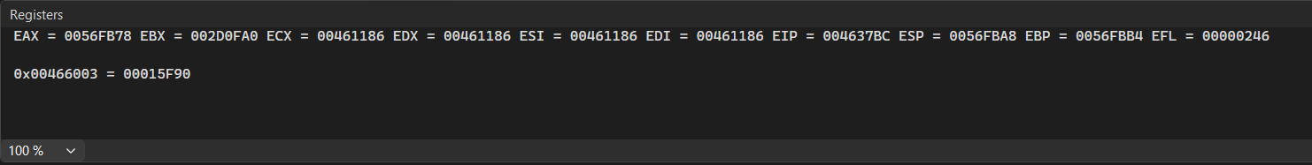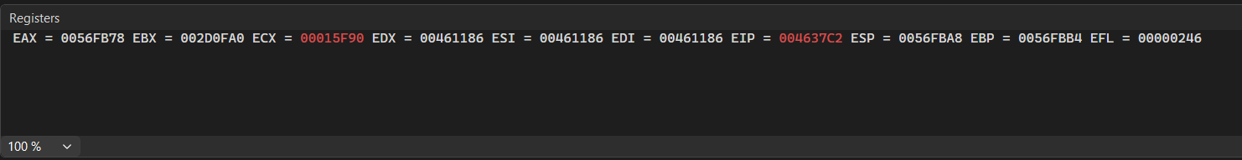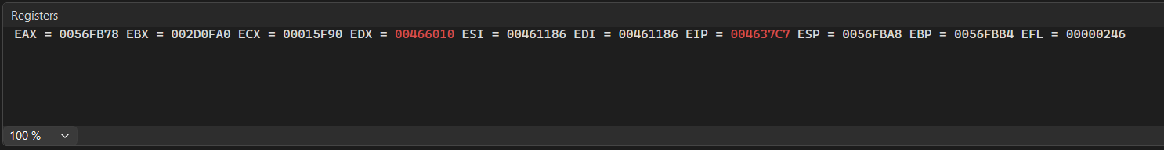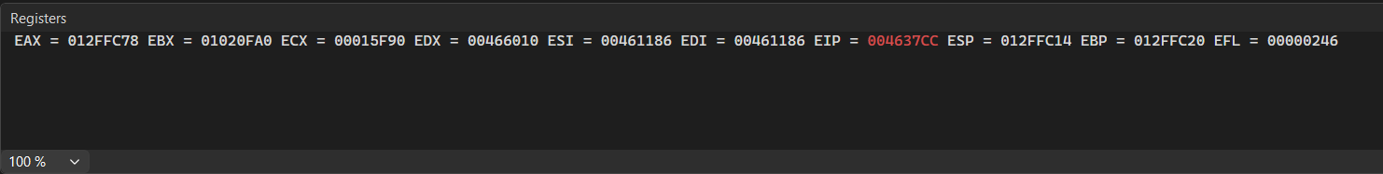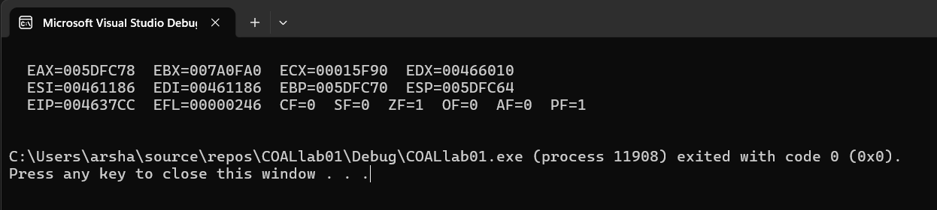
TASK 4:
INCLUDE Irvine32.inc

.data
signedByte SBYTE -100
unsignedByte BYTE 200
wordVal WORD 60000
dwordVal DWORD 3000000
qwordVal QWORD 500000000000
charVal BYTE 'Z'
strVal BYTE "Data Types", 0

.code
main PROC ;breakpoint
mov al, unsignedByte
mov bl, signedByte
mov cx, wordVal
mov edx, dwordVal

call DumpRegs
exit
main ENDP
END main

